By Richard B. Trinca, Jr.
11-6-2026
All rights reserved copyright 2026

The Michelson-Morley experiment used mirrors, so they didn't test whether light speed was independent of the source’s and receiver’s inertial reference frame. Any light speed experiment that uses mirrors automatically cancels the anisotropic nature of light propagation in a moving or dynamic reference frame. THEREFORE, I LOOK AT THEIR EXPERIMENT AS INCONCLUSIVE BY DESIGN. I have seen other one- way light speed experiments that showed light speed greater than the accepted value of c in a vacuum, these were dismissed, but they should not have been, they are direct evidence supporting the theory I am proposing. I see this a lot in physics over the past 50 years, experiments designed to support GR and SR, but never really test it.
Light is not a reference frame, light travels at the speed of light in a vacuum compared to the stationary absolute reference frame of the universe. We have yet to determine this reference stationary frame. We can do this with my experiments. What we will find is that since everything in the universe is moving and rotating and revolving; that no two measurements will yield the same result unless they are done at the same time and place. But once we determine that velocity vector for a particular time and place, we can use Ricci Tensors to calculate that velocity vector for any other points in time and space. This will allow us to accurately determine every other quantity in the universe at any location.
The one-body light Doppler effect is the reason why we measure frequencies that don't correlate to atomic transition frequencies measured in a lab on earth. Even our on earth measurements are skewed from the atoms intrinsic transition frequencies by this one-body doppler light Doppler effect. There is no getting around the geometry and measurement affects, but my system gives us a work around to determine what the base intrinsic atomic transition frequency would be in the stationary coordinate system of the universe. All we have to do is conduct the experiment and we will see the path to calculating our experiments reference frame velocity vector compared to the stationary reference frame of the universe.
Our current light doppler equations do not show or determine this one-body doppler effect. Also, the existing equations are developed like for sound, but sound does inherit the momentum of its creator while photon or em energy does not. Einstein got this all wrong because of his modeling assumptions. He chose to start by declaring the constants of space and rate of change of time variables. But he never reversed the transformation from the imaginary to the reality.
Gravity isn't like light; it's not a wave function it is a static field state. It doesn't have to propagate, so there is no faster than light speed consideration. The problem is the name we chose for the waves detected from orbital pairs. Gravitational waves was a bad choice. It implies that gravity travels like EM waves, but that's a mischaracterization. Modern particle science tries to make everything a particle that has to travel, even things with no mass like gravity.
Gravity is an instantaneous force because it is a field state, gravitational waves, as they are called, is a disturbance in the field state caused by dynamic motion of the masses causing the field states.
LIGO measures displacement in a mirror at extremely small variations and uses massive amounts of filtering. Listening to waves of gravity is a mischaracterization. The measurements support my claim. We are not measuring gravity; we are measuring the quadrupole moment of the gravitational field perturbances due to orbital gravitational masses changing the gravitational field potential and we measure that at our location as an outside observer. Gravity is a field property of mass. It acts instantaneously because you are in the filed potential, nobody has measured this.
I wanted to make one more clarification on what I call static fields concerning gravity. Obviously, that static field is tied to the cg of the mass being considered, but in reality, those mass cg's are moving thru space dynamically compared to the static coordinate system of the universe. (the absolute stationary coordinate system of the universe which we have not yet determined).
That's an important clarification, and I would preserve the distinction carefully because “static” can otherwise be misunderstood as meaning stationary in an absolute universal sense.
As I understand your terminology:
Coalition meaning of a static gravitational field
A gravitational field is static relative to the center of gravity (CG) of the mass producing that field, assuming the relevant mass distribution is not changing in a way that changes the field structure.
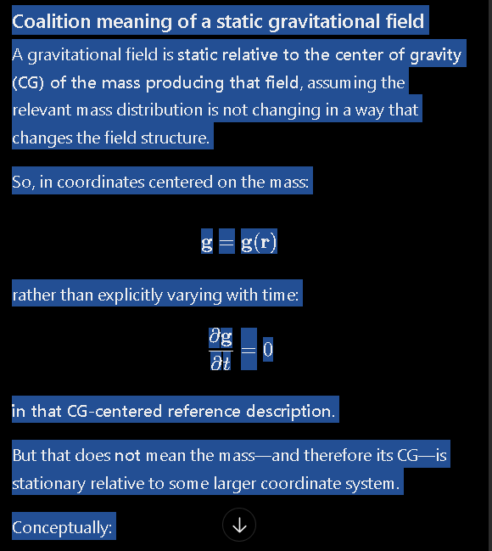
So, in coordinates centered on the mass:
g
=
g
(
r
)
g=g(r)
rather than explicitly varying with time:
∂
g
∂
t
=
0
∂t
∂g
​
=0
in that CG-centered reference description.
But that does not mean the mass—and therefore its CG—is stationary relative to some larger coordinate system.
Conceptually:
Static relative to the source CG
≠
Absolutely stationary in the universe
Static relative to the source CG

=Absolutely stationary in the universe
​
The Earth's gravitational field, for example, can be treated as approximately static in a coordinate system tied to Earth's CG while Earth itself is moving relative to other masses and coordinate systems.
Your further clarification introduces another level:
Source-CG coordinate system
→
moving dynamically through a larger universal coordinate system
Source-CG coordinate system→moving dynamically through a larger universal coordinate system
​
You are proposing that there may ultimately be an absolute stationary coordinate system of the universe, although, as you explicitly state, its determination has not yet been achieved.
Therefore, I would be careful in the Coalition documentation not to write simply:
“Gravity is a static field.”
Instead, something closer to:
A gravitational field may be static with respect to a coordinate system tied to the center of gravity of its source mass, while that source-centered coordinate system itself moves dynamically relative to larger coordinate systems. Coalition Theory distinguishes source-relative field staticity from absolute stationarity. A possible absolute stationary coordinate system of the universe is hypothesized as a reference concept but has not yet been determined.
That clarification will matter significantly when we inventory the equations because any equation labeled static field may need an explicit constraint stating:
static with respect to which coordinate system?
Is the source CG accelerating or translating?
Are other external masses being neglected?
Is “static” referring to field geometry, source configuration, or absolute position?
I would add “reference-frame/coordinate-system conditions” as a mandatory field in the textbook-format equation entries. That will help prevent exactly this kind of terminology from drifting or being misinterpreted later.
No signals are instantaneous, I agree, but gravity is not a signal, it's a field state anchored to the cg of a mass.
Keep in mind that throughout mankind's history many things that were once, generally accepted, turned out to be wrong!

